Python - Calculating pi

**Question 1**



(1)

$$\frac{d}{dx}tan^{-1}\left(x\right)=\frac{1}{1+x^{2}}=1-x^{2}+x^{4}-x^{6}+x^{8}$$

Then we can integrate to give,

(2)



$$tan^{-1}\left(x\right)=\int{1-x^{2}+x^{4}-x^{6}+x^{8}} \\ =x-\frac{x^{3}}{3}+\frac{x^{5}}{5}-\frac{x^{7}}{7}+\frac{x^{9}}{9}$$

Using the triangle given, we have **Eq.3**. Where $x=\frac{1}{\sqrt{3}}$

(3)

$$π=6\tan^{-1}\left(x\right)= x-\frac{x^{3}}{3}+\frac{x^{5}}{5}-\frac{x^{7}}{7}+\frac{x^{9}}{9}…$$

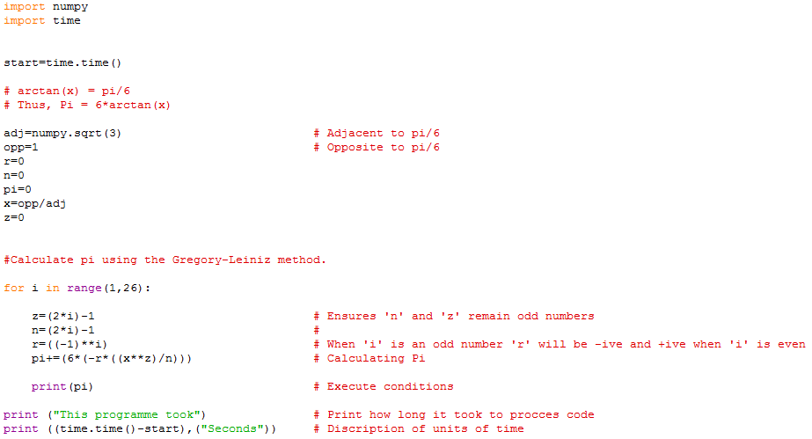

**Fig 1.1** Code used to calculate $π$,using the Gregory-Liniz method. Discribing the infinaite sereis from **Eq.3.**

Line 26

‘ $z$’ and ‘ $n$’ will alwas remain negative as ‘ $i$’ increases. Going up in incrments of 2. They also remain the same value as per **Eq.3**.

The ‘ $r$’ term is responsiable for alternating the series between negative and possitive. When ‘ $i$’ is even, ‘ $r$’ will render the term possotive and visa versa. Hence the series alternates between negative and possative terms.

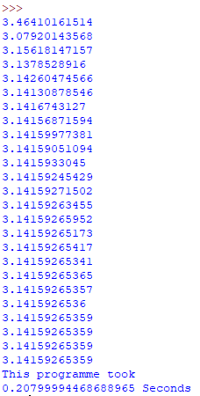

**Fig 1.2** Shows the output from the code used in **Fig 1.1**.

23rd term in range.

**Fig 1.2** Shows how long it took to compile the code from **Fig 1.1** in seconds**.** It also shows us how many terms was necessary before our degree of accuracy became unchanging.

**Fig 1.2** shows that the algorithm becomes less accurate after 23 terms. Even increasing the range to 1 to 500 as per **Fig 1.3** had no effect on the accuracy of our result.



**Fig 1.3** Increasing the range from 26 to 500



1. 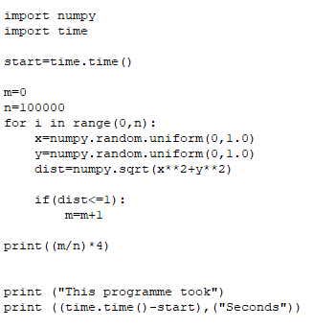

**Fig 1.4** shows the code for Monte CarloMethod of calculating $π$.

The *Monte Carlo* method for caluating $π$ uses a random number genertor to calculate $π$ and can be to varying degrees of accuarcy every time it is ran (Unless seeded). For this method, the range was from 1 to 9999 and was only correct to 2 decimal places. Unlike the Gregory-Liniz method from **Fig 1.1** which was only in the range 1 to 25 which was true upto 10 decimal places.

.

**Fig 1.5** shows the accuracy and time it took for the Monte Carlo method.



Looking at **Fig 1.5** It took the Monte Carlo far longer to to run (0.34 seconds) than the Gregory-Liniz method (0.21 seconds) from **Fig 1.2**. This is mainly due to the extented range used with the Monte Carlo. However if we lowered the range it to thatt of **Fig 1.2** then the accuracey would be way off. Thus I conclude that the the Gregory-Liniz method is far quicker and far more effective than the random natured Monte Carlo method.